# Algorithm for file updates in Python

## Project description

The algorithm is to import and write to files that have a range of ip addresses in being able to update this list with allowed ip addresses and removing ip addresses updating the file.

## Open the file that contains the allow list

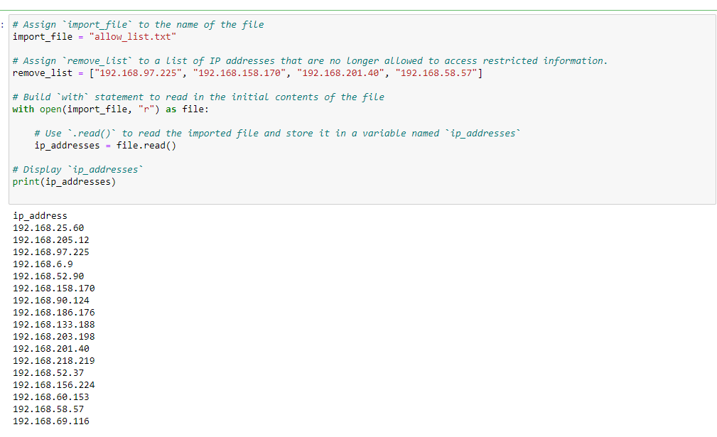

Opens the import file - with open(import_file, “r”) as file:

## Read the file contents



Reads the import file contents - with open(import_file, “r”) as file:

As the r means its being opened as read

## Convert the string into a list

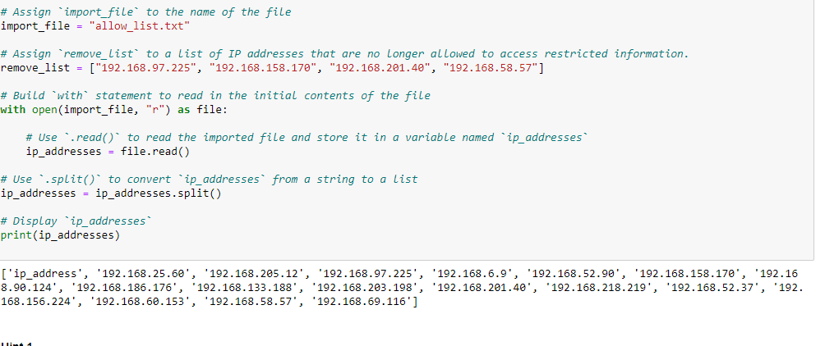

Takes ip_addresses variable which is the file and then splits it converting the string to a list

## Iterate through the remove list

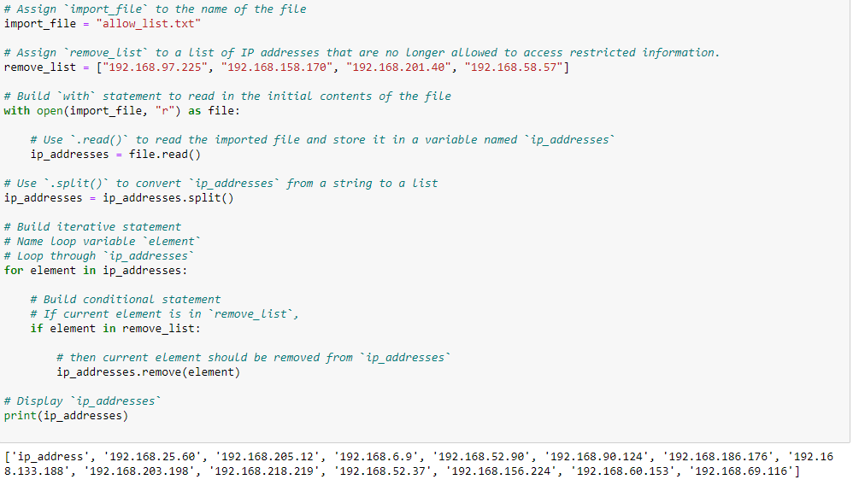

I'm iterating the ip addresses list with a for loop which then goes to an if statement that checks the remove list.

## Remove IP addresses that are on the remove list



I'm iterating the ip addresses list with a for loop and it is checking that if an element in the list is in the remove list then it removes that element with the .remove(element) .

## Update the file with the revised list of IP addresses

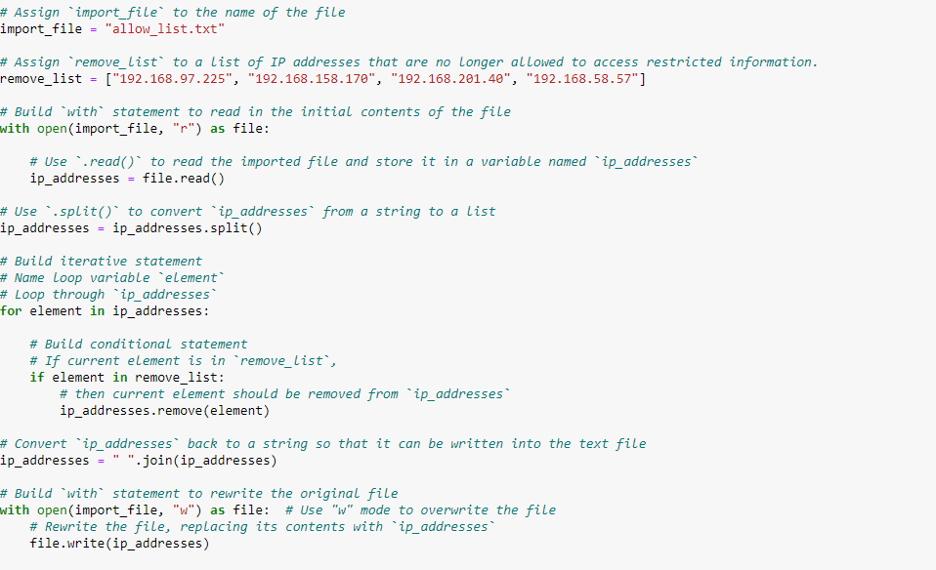

Using with open(import_file, “w”) as file:

Allows for the file to be written then using the file.write will edit the ip_addresses file

## Summary

Have learned how to make an algorithm that will read/write to a text file in python and understand how this can be used to manage ip addresses/log files